PROJECT REPORT

*INVENTORY MANAGEMENT SYSTEM FOR RETAILERS*

***SUBMITTED BY***

**PNT2022TMID48008**

**JANANI J**

**BAVADHARANI M**

**DEVI PRIYA J**

**PAVITHRA** S

**TABLE OF CONTENTS**

1. **INTRODUCTION**
   1. Project Overview
   2. Purpose
2. **LITERATURE SURVEY**
   1. Existing problem
   2. References
   3. Problem Statement Definition
3. **IDEATION & PROPOSED SOLUTION**
   1. Empathy Map Canvas
   2. Ideation & Brainstorming
   3. Proposed Solution
   4. Problem Solution fit
4. **REQUIREMENT ANALYSIS**
   1. Functional requirement
   2. Non-Functional requirements
5. **PROJECT DESIGN**
   1. Data Flow Diagrams
   2. Solution & Technical Architecture
   3. User Stories
6. **PROJECT PLANNING & SCHEDULING**
   1. Sprint Planning & Estimation
   2. Sprint Delivery Schedule
7. **CODING & SOLUTIONING (Explain the features added in the project along with code)**
   1. Feature 1
   2. Feature 2
   3. Database Schema (if Applicable)
8. **TESTING**
   1. Test Cases
   2. User Acceptance Testing
9. **RESULTS**
   1. Performance Metrics
10. **ADVANTAGES & DISADVANTAGES**
11. **CONCLUSION**
12. **FUTURE SCOPE**
13. **APPENDIX**

Source Code, GitHub & Project Demo Link

# INTRODUCTION

* 1. **PROJECT OVERVIEW**

With IBM Cloud IaaS, organizations can deploy and access virtualized IT resources -- such as compute power, storage and networking -- over the internet. For compute, organizations can choose between bare-metal or virtual servers.

With IBM Cloud PaaS -- which is based on the open source cloud platform Cloud Foundry -- developers can use IBM services to create, manage, run and deploy various types of applications for the public cloud, as well as for local or on-premises environments. IBM Cloud supports various programming languages, such as Java, Node.js, PHP and Python and extends to support other languages.

* 1. **PURPOSE**

In practice, effective retail inventory management results in lower costs and a better understanding of sales patterns. Retail inventory management tools and methods give retailers more information on which to run their businesses. Applications have been developed to help retailers track and manage stocks related to their own products. The System will ask retailers to create their accounts by providing essential details. Retailers can access their accounts by logging into the application.

# LITERATURE SURVEY

* 1. **EXISTING PROBLEM**

Inventory Management System is an integral part of all organizations to manage the information about availability of items in stock and its issues and returns. In this post we will learn how to create a simple online Inventory Management System that allows you to add items, accept requests from employees and Issue items against their requests. The non- consumable items can be returned thus updating the stock.

**REFERENCES**

**The relationship of financial and inventory performance of manufacturing firms in Indian context.**

Gaur and Bhattacharya (2011)

Attempted to study the linkage between the performance of the components of inventory such as raw material, work in progress and finished goods and financial performance of Indian manufacturing firms. The study revealed that finished goods inventory as inversely associated with business performance while raw material inventory and work in progress did not have much effect on same. They emphasised that instead of focusing on total inventory, an attempt should be made to concentrate on individual components of inventory so as to adequately manage the same. They concluded that managers not paying heed to inventory performance may become weak in combating competitors.

Inventory management practices and business performance for small scale enterprises in Kenya.

Nyabwanga and Ojera (2012)

They Highlighted the association between inventory management practices and business performance of smallscale enterprises (SSEs), in Kisii Municipality, Kisii County, Kenya. They used a cross-sectional survey study based on a small sample size of 79 SSEs. The empirical results disclosed that a positive significant relationship existed between business performance and inventory management practices with inventory budgeting having the maximum influence on business performance.

Impact of inventory management on the profitability of SMEs in Tanzania

Madishetti, Srinivas & Kibona, Deogratias. (2013).

A survey conducted on all the eight (8) sugar manufacturing firms in Kenya established that there is generally positive correlation between each of inventory management practices.

Specific performance indicators were proved to depend on the level of inventory management practices.

They established that Return on Equity had a strong correlation with lean inventory system and strategic supplier partnerships.

As such, they concluded that the performance of sugar firms could therefore be stated as being a function of their inventory

International Journal of Engineering Research

## Srinivas Rao Kasisomayajula(2014)

An analytical study was conducted on” Inventory Management in Commercial Vehicle Industry In India”. A sample of five companies’ was selected for study. The study concluded that all the units in the commercial vehicle industry have significant relationship between Inventory and Sales. Proper management of inventory is important to maintain and improve the health of an organization. Efficient management of inventories will improve the profitability of the organization

2.1 PROBLEM STATEMENT DEFINITION

## Irrespective of the size of the business, inventory management is one of the most challenging processes in the retail sector.

In this industry, the efficiency of inventory management directly impacts customer satisfaction. As retail is a fast-paced, and customer-facing sector, customer satisfaction is core to its business growth.

## The inventory process involves multiple intricate aspects that drive accurate product delivery. Even a single error in the process can have expensive and long-term consequences. This will eventually affect the company’s growth and reputation.

Thus, retail companies need to understand and analyze the risks involved in inventorymanagement. Only then can companies find proactive solutions to the problems.

# IDEATION AND PROPOSED SOLUTION

* 1. **EMPATHY MAP CANVAS**

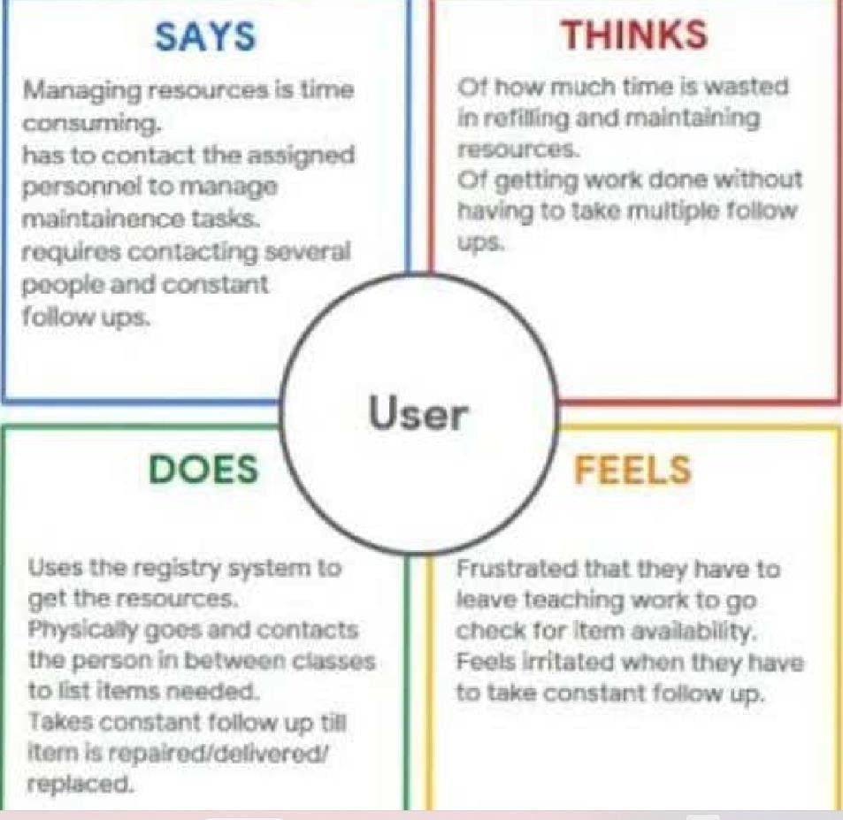

* 1. **Ideation& Brainstorming**

Step-1: Team Gathering, Collaboration and Select the Problem Statement

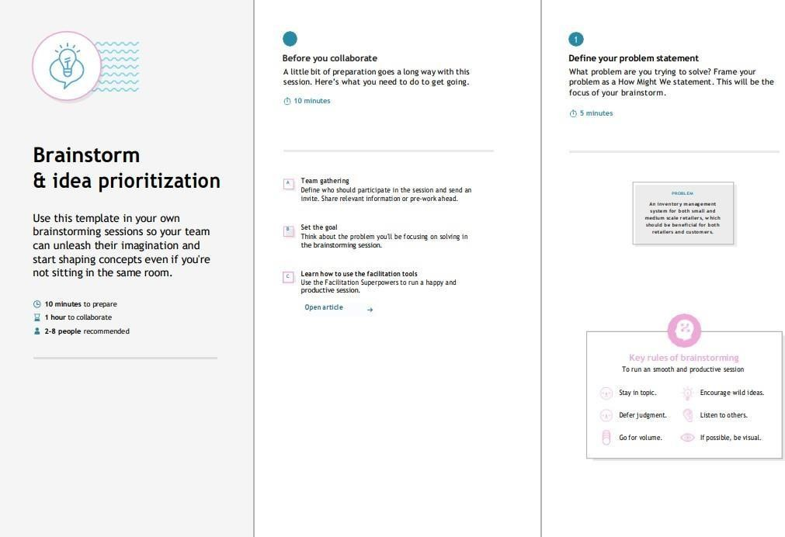

Step-2: Brainstorm, Idea Listing and Grouping

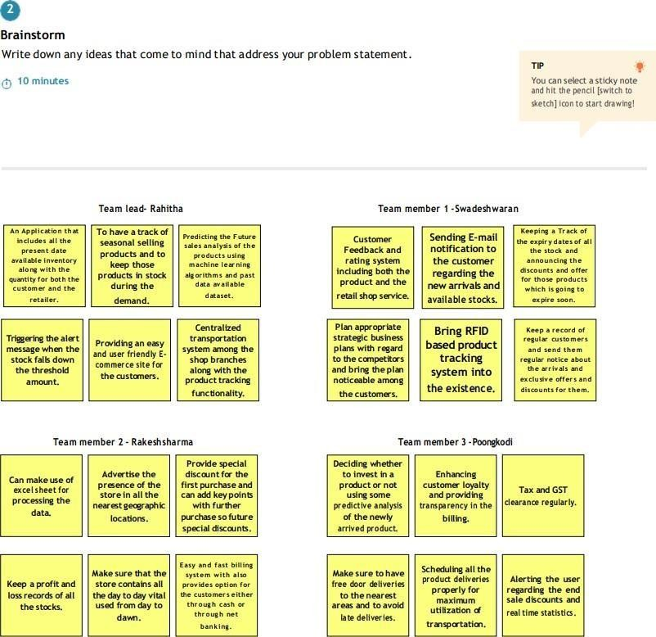

Step-3: Idea Prioritization

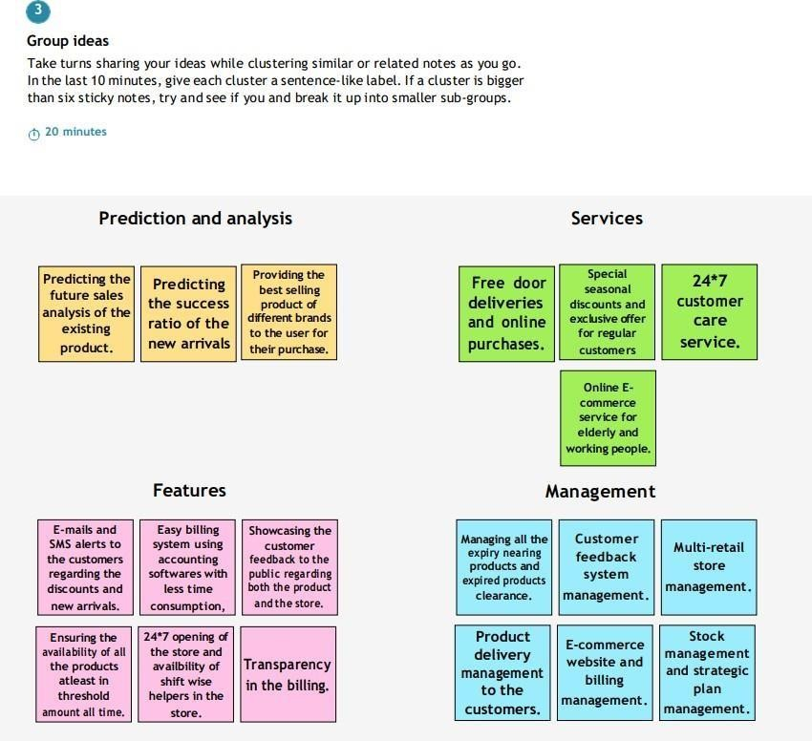

PROPOSED SOLUTION

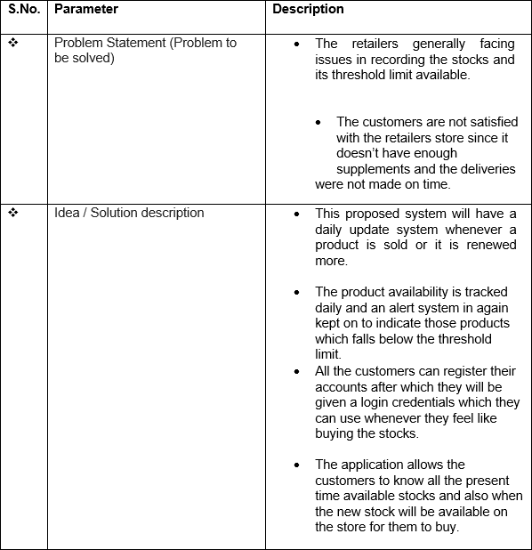

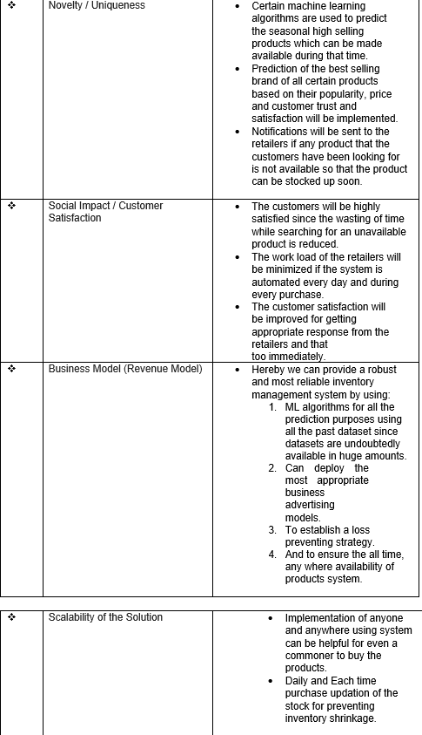

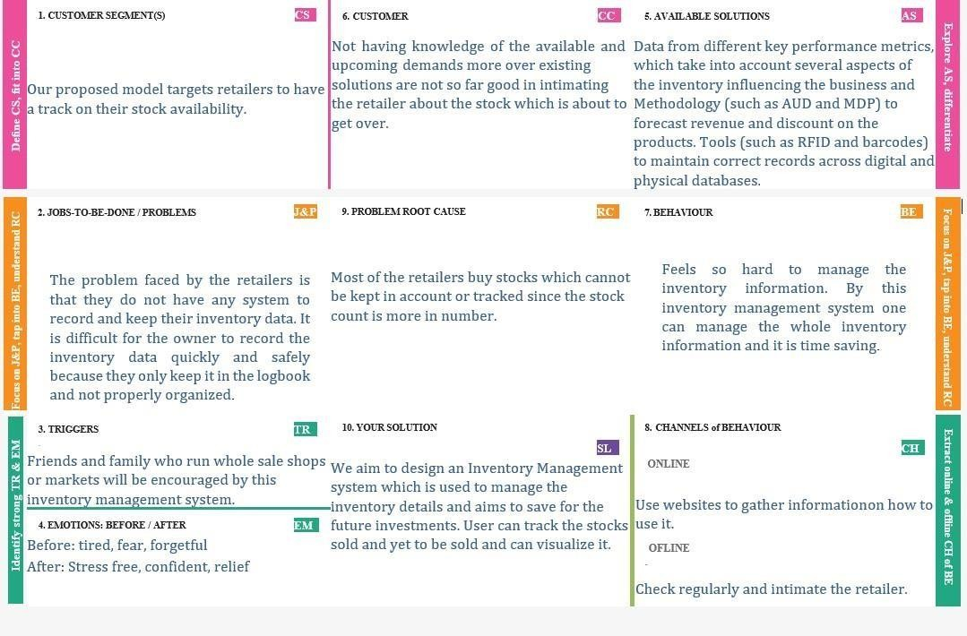

* 1. **PROBLEM SOLUTION FIT**

+

|  |  |  |  |
| --- | --- | --- | --- |
| **4. REQUIREMENT ANALYSIS**  4.1 **FUNCTIONAL REQUIREMENTS** | | | |
| **FR.**  **No.** | **Functional Requirement**  **(Epic)** | **Sub Requirement (Story/Sub-Task)** |  |
| FR-1 | User Registration | Registration through registration form.  Registration through One-Tap Google Sign- in. |
| FR-2 | User Authentication and Confirmation | Authentication via Google Authentication. Confirmation via Email.  Confirmation via OTP. |
| FR-3 | Product management | Quickly produce reports for single or multiple products.  Track information of dead and fast-moving products.  Track information of suppliers and manufacturers of the product. |
| FR-4 | Audit Monitoring | The technique of tracking crucial data is known as audit tracking.  Monitor the financial expenses carried out throughout the whole time (from receiving order of the product to delivery of the  product). |
| FR-5 | Historical Data | Data of everything should be stored for analytics and forecasting. |
|  | | | |

* 1. **Non-functional Requirements:**

|  |  |  |
| --- | --- | --- |
| **FR**  **No.** | **Non-**  **Functional Requirement** | **Descript ion** |
| NFR-1 | Usability | The UI should be accessible toeverybodydespite of there diversity in languages.  People with some impairments should also be able to use the application with ease. (Example, integrate google assistant so that blind people can use it).  . |
| NFR-2 | Security | The security requirements deal with the primary security. Only authorized users canaccess the systemwith their credentials.  Administrator or the concerned security team shouldbe alerted on any unauthorized access or data breaches so  as to rectify it immediately. |
| NFR-3 | Reliability | The software should be able to connect tothe database in the event of the server |

|  |  |  |
| --- | --- | --- |
|  |  | The users must me intimated by the  periodic maintenance break of the server so that they will be aware of it. |
| NFR-4 | Performance | Performance of the app should be  reliable with high-end servers on which the software is running. |

# PROJECT DESIGN

* 1. **DATA FLOW DIAGRAM**

A Data Flow Diagram (DFD) is a traditional visual representation of the information flows within a system. A neat and clear DFD can depict the right amount of the system requirement graphically. It shows how data enters and leaves the system, what changes the information, and where data is stored.

**Example:(Simplified)FLOW**

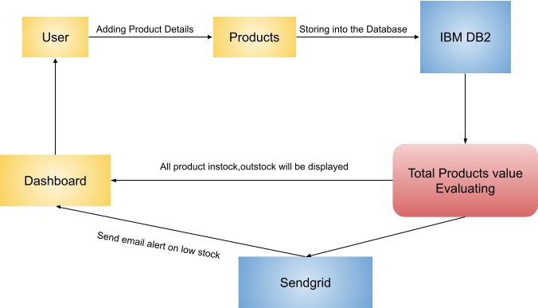

* 1. **SOLUTION & TECHNICAL ARCHITECTURE**

Solution architecture is a complex process – with many sub-processes – that bridges the gap between business problems and technology solutions. Its goals are to:

* + - Find the best tech solution to solve existing business problems.
    - Describe the structure, characteristics, behavior, and other aspects of the software to project stakeholders.
    - Define features, development phases, and solution requirements.
    - Provide specifications according to which the solution is defined, managed, and delivered

Solution Architecture Diagram:

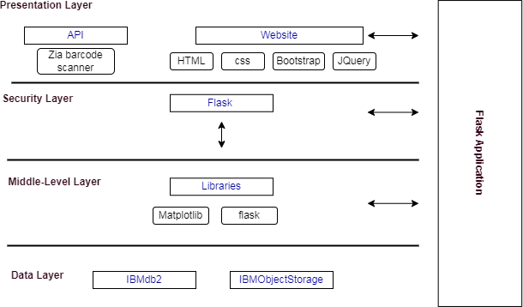

*Figure 1: Model Architecture of the cloud development for retailers*

* 1. **USER STORIES**

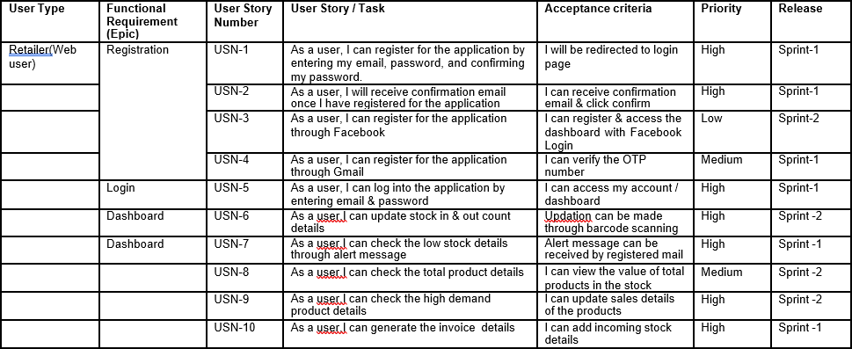

6.2 SPRINT DELIVERY SCHEDULE

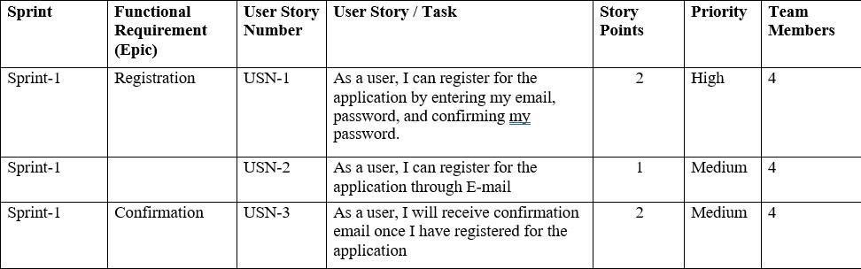

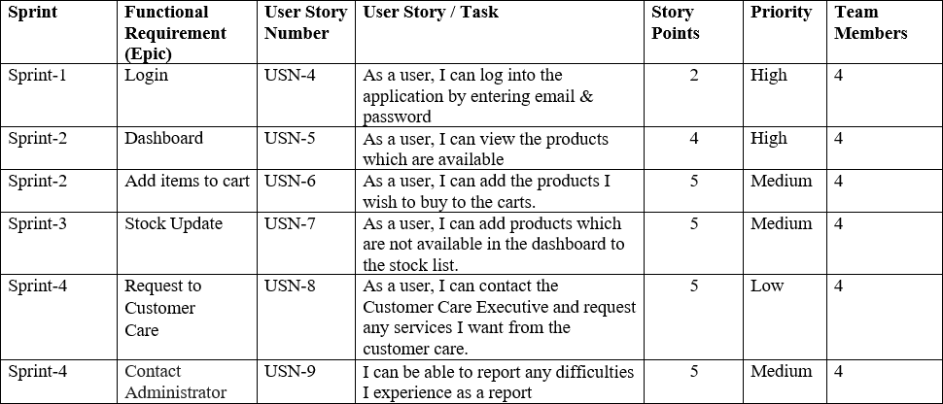

1. **CODING & SOLUTIONING**
   1. **FEATURE 1**
      * track raw material and finished goods for manufacturers
      * track lot numbers, FDA, and recall
      * support for kitting and costing of kits from components and labor
   2. **FEATURE 2**
      * Business owners manage the inventory well with the help of inventory software. Managers balance the demand and supply of the company products efficiently.
      * This is why businesses are capable of generating a huge amount of revenue on an annual basis.
   3. **DATABASE SCHEMA (IF APPLICABLE)**
      * The shop has an inventory of products. Each product has a price, but this price should vary depending on sales.
      * Customers can make orders for multiple products at a time, and should be able to see their order history.
      * When the order has been completed, there should be a track and trace number.

import os

import numpy as np

from flask import Flask, render_template, request, send_from_directory, url_for

#from gevent.pywsgi import WSGIServer from keras.models import load_model from keras.preprocessing import image from PIL import Image

from werkzeug.utils import redirect, secure_filename

UPLOAD_FOLDER = 'D:/NalaiyaThiran/projFiles/data'

app = Flask( name ) app.config['UPLOAD_FOLDER'] = UPLOAD_FOLDER

model = load_model("./model/mnist_digit_recog_cnn.h5")

@app.route('/') def index():

return render_template('index.html')

@app.route('/web', methods=['GET', 'POST']) def web():

if request.method == "POST": f = request.files["image"]

basepath = os.path.dirname( file )

filepath = os.path.join(basepath, 'data', f.filename) f.save(filepath)

# img = image.load_img(filepath, target_size=(64, 64)) # x = image.img_to_array(img)

# x = np.expand_dims(x, axis=0)

# filepath = secure_filename(f.filename)

# f.save(os.path.join(app.config['UPLOAD_FOLDER'], filepath))

# upload_img = os.path.join(UPLOAD_FOLDER, filepath)

img = Image.open(filepath).convert("L") # convert image to monochrome

img = img.resize((28, 28)) # resizing of input image

im2arr = np.array(img) # converting to image

im2arr = im2arr.reshape(1, 28, 28, 1) # reshaping according to our requirement

pred = model.predict(im2arr)

num = np.argmax(pred, axis=1) # printing our Labels

return render_template('web.html', num=str(num[0])) return render_template('web.html')

if name == ' main ': app.run(debug=True, threaded=False)

1. **TESTING**
   1. **TEST CASE**

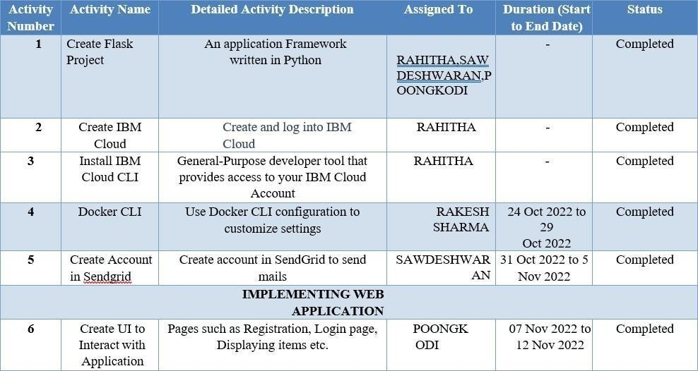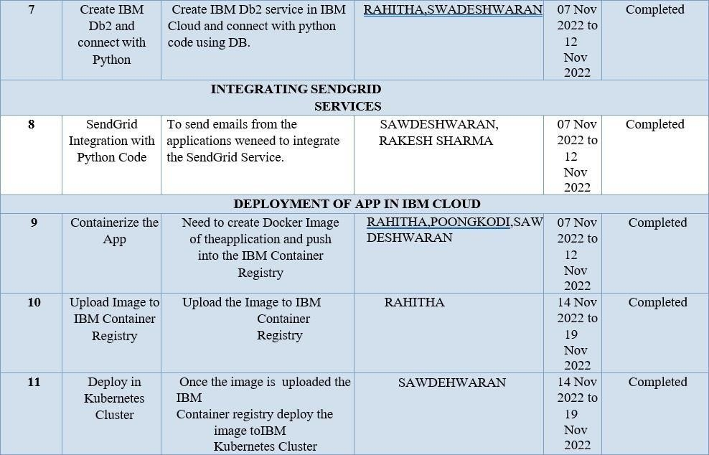

* 1. **USER ACCEPTANCE TESTING**

1. **Defect Analysis**

This report shows the number of resolved or closed bugs at each severity level, and how they were resolved

|  |  |  |  |  |  |
| --- | --- | --- | --- | --- | --- |
| **Resolution** | **Severity 1** | **Severity 2** | **Severity 3** | **Severity 4** | **Subtotal** |
| By Design | 0 | 0 | 0 | 0 | 0 |
| Duplicate | 0 | 0 | 0 | 0 | 0 |
| External | 0 | 0 | 0 | 0 | 0 |
| Fixed | 0 | 0 | 0 | 0 | 0 |
| Not Reproduced | 0 | 0 | 0 | 0 | 0 |
| Skipped | 0 | 0 | 0 | 0 | 0 |
| Won't Fix | 0 | 0 | 0 | 0 | 0 |
| Totals | 0 | 0 | 0 | 0 | 0 |

1. **Test Case Analysis**

This report shows the number of test cases that have passed, failed, and untested

|  |  |  |  |  |
| --- | --- | --- | --- | --- |
| **Section** | **Total Cases** | **Not Tested** | **Fail** | **Pass** |
| Client Application | 5 | 0 | 0 | 5 |
| Security | 5 | 0 | 0 | 5 |
| Final Report Output | 5 | 0 | 0 | 5 |
| Version Control | 5 | 0 | 0 | 5 |

1. **RESULTS**
   1. **PERFORMANCE METRICS**

|  |  |  |  |
| --- | --- | --- | --- |
| **S.No.** | **Parameter** | **Values** | **Screenshot** |
| 1. | Model Summary | **-** |  |
| 2. | Accuracy | Training Accuracy – 99%  Validation Accuracy –  97% |  |
| 3. | Confidence Score (OnlyYolo Projects) | Class Detected -  Confidence Score - |  |

1. **ADVANTAGES & DISADVANTAGES**

ADVANTAGE

* Real-time inventory tracking helps you improve inventory management and ensures that you have optimal stock available to fulfill orders.
* However, for most retail businesses, the inventory accuracy is merely [63%](https://blog.flexis.com/5-inventory-management-stats-worth-knowing). With accurate inventory tracking, you can eliminate over-stocking, and in turn, reduce the cost and manual efforts required in holding it.
* There are many ways to improve inventory efficiency. Some of the most proven methods include:

.

* **DISADVANTAGE**
  + Not 100% accurate, there are likely to be some mistakes made during the method.

1. **CONCLUSION**

Feedback offers retailers a valuable tool to improve the way they engage with

customers.

It lets customers know their opinion matters.

It shows that retailers listen to their customers, value their opinion, and care

about their experience.

1. **FUTURE SCOPE**

Inventory may be seen as the bloodstream of any competitive business. Its unobstructed flow is

critical

Like the life-sustaining “oxygen” that is carried by the blood to various parts of the human

body,

Like the doctor who extracts a few samples of blood from a patient’s arm in order to evaluate

health.

Accumulation of unnecessary inventory is frequently symptomatic of bigger problems that lurk Its significance cannot be overstated.

1. **APPENDIX**

**SOURCE CODE**

Index.html

<!DOCTYPE html>

<html lang="en">

<head>

<meta charset="UTF-8" />

<meta http-equiv="X-UA-Compatible" content="IE=edge" />

<meta name="viewport" content="width=device-width, initial-scale=1.0" />

<title>Sidebar Menu</title>

<link href=["http](https://cdn.jsdelivr.net/npm/bootstrap%405.2.2/dist/css/bootstrap.min)s[://cdn.jsdelivr.net/npm/bootstrap@5.2.2/dist/css/bootstrap.min.](https://cdn.jsdelivr.net/npm/bootstrap%405.2.2/dist/css/bootstrap.min) css" rel="stylesheet"

integrity="sha384- Zenh87qX5JnK2Jl0vWa8Ck2rdkQ2Bzep5IDxbcnCeuOxjzrPF/et3URy9Bv1WTR i" crossorigin="anonymous" />

<link rel="stylesheet" href="static/css/style.css" />

</head>

<body>

<div class="wrapper">

<!-- Sidebar -->

<nav id="sidebar">

<div class="sidebar-header">

<h3>Inventory</h3>

</div>

<ul class="list-unstyled components">

<li class="active">

<a>Dashboard</a>

</li>

<li>

<a href="#">Add item</a>

</li>

<li>

<a href="#pageSubmenu">Pages</a>

</li>

<li>

<a href="#">delete items</a>

</li>

<li>

<a href="#">Help</a>

</li>

</ul>

</nav>

<!-- Page Content -->

<div id="content">

<h2>Dashboard</h2>

<p>

Lorem ipsum dolor sit amet, consectetur adipisicing elit, sed do eiusmod tempor incididunt ut labore et dolore magna aliqua. Ut enim

ad

minim veniam,

</p>

</div>

</div>

<nav class="navbar navbar-expand-lg bg-light">

<div class="container-fluid">

<a class="navbar-brand" href="#">Navbar</a>

<button class="navbar-toggler" type="button" data-bs-toggle="collapse" data-bs-target="#navbarNavDropdown"

aria-controls="navbarNavDropdown" aria-expanded="false" aria- label="Toggle navigation">

<span class="navbar-toggler-icon"></span>

</button>

<div class="collapse navbar-collapse" id="navbarNavDropdown">

<ul class="navbar-nav">

<li class="nav-item">

<a class="nav-link active" aria-current="page" href="#">Home</a>

</li>

<li class="nav-item">

<a class="nav-link" href="#">Features</a>

</li>

<li class="nav-item">

<a class="nav-link" href="#">Pricing</a>

</li>

<li class="nav-item dropdown">

<a class="nav-link dropdown-toggle" href="#" role="button" data-bs- toggle="dropdown" aria-expanded="false">

Dropdown link

</a>

<ul class="dropdown-menu">

<li><a class="dropdown-item" href="#">Action</a></li>

<li><a class="dropdown-item" href="#">Another action</a></li>

<li>

<a class="dropdown-item" href="#">Something else here</a>

</li>

</ul>

</li>

</ul>

</div>

</div>

</nav>

<nav>

<div class="search">

<i class="bx bx-search"></i>

<input type="text" class="hide" placeholder="Quick Search ..." />

</div>

<div class="sidebar-links">

<ul>

<div class="active-tab"></div>

<li class="tooltip-element" data-tooltip="0">

<a href="#" class="active" data-active="0">

<div class="icon">

<i class="bx bx-tachometer"></i>

<i class="bx bxs-tachometer"></i>

</div>

<span class="link hide">Dashboard</span>

</a>

</li>

<li class="tooltip-element" data-tooltip="1">

<a href="#" data-active="1">

<div class="icon">

<i class="bx bx-folder"></i>

<i class="bx bxs-folder"></i>

</div>

<span class="link hide">Products</span>

</a>

</li>

<li class="tooltip-element" data-tooltip="2">

<a href="#" data-active="2">

<div class="icon">

<i class="bx bx-message-square-detail"></i>

<i class="bx bxs-message-square-detail"></i>

</div>

<span class="link hide">Add items</span>

</a>

</li>

<li class="tooltip-element" data-tooltip="3">

<a href="#" data-active="3">

<div class="icon">

<i class="bx bx-bar-chart-square"></i>

<i class="bx bxs-bar-chart-square"></i>

</div>

<span class="link hide">Remove items</span>

</a>

</li>

<div class="tooltip">

<span class="show">Dashboard</span>

<span>Projects</span>

<span>Messages</span>

<span>Analytics</span>

</div>

<li class="tooltip-element" data-tooltip="1">

<a href="#" data-active="5">

<div class="icon">

<i class="bx bx-help-circle"></i>

<i class="bx bxs-help-circle"></i>

</div>

<span class="link hide">Help</span>

</a>

</li>

<li class="tooltip-element" data-tooltip="2">

<a href="#" data-active="6">

<div class="icon">

<i class="bx bx-cog"></i>

<i class="bx bxs-cog"></i>

</div>

<span class="link hide">Settings</span>

</a>

</li>

<div class="tooltip">

<span class="show">Tasks</span>

<span>Help</span>

<span>Settings</span>

</div>

</ul>

</div>

<div class="sidebar-footer">

<a href="#" class="account tooltip-element" data-tooltip="0">

<i class="bx bx-user"></i>

</a>

<div class="admin-user tooltip-element" data-tooltip="1">

<div class="admin-profile hide">

<img src="./img/face-1.png" alt="" />

<div class="admin-info">

<h3>Ganesh</h3>

<h5>user</h5>

</div>

</div>

<a href="#" class="log-out">

<i class="bx bx-log-out"></i>

</a>

</div>

<div class="tooltip">

<span class="show">Ganesh</span>

<span>Logout</span>

</div>

</div>

</nav>

<main>

<h1>My Dashboard</h1>

</main>

<script src="static/js/app.js"></script>

</body>

</html>

login.html:

{% extends 'base.html '%}

{% block head %}

<title>Login page</title>

{% endblock%}

{%block body%}

<main class="container ">

<div class="mx-auto mt-5 border bg-light login-card " style="width:500px;">

<h2 class='mx-4 mt-2'>LOGIN</h2>

<form action="{{url_for('login') }}" method="post">

<div class="mx-4 mt-2 text-danger">{{ msg }}</div>

<div class="my-2 mx-4">

<label for="username">username</label>

<input type="text" class="form-control" placeholder=["adc@gm](mailto:adc@gmail.com)a[il.com](mailto:adc@gmail.com)" name="username" required />

</div>

<div class="my-2 mx-4">

<label for="password_1">password</label>

<input type="password" class="form-control" name="password_1" required />

</div>

<input type="submit" value="submit" class="btn btn-primary my-4 mt-2 mx-4" />

</form>

<p>Don't have an account?<a href="{{ url_for('signup') }}"> Sign Up</a>

</div>

</main>

</p>

</main>

{% endblock%}

App.py

from flask import Flask, render_template, url_for, request, redirect, session, make_response

import sqlite3 as sql

from functools import wraps import re

import ibm_db

conn = ibm_db.connect("DATABASE=bludb;HOSTNAME=815fa4db-dc03-4c70- 869a-

a9cc13f33084.bs2io90l08kqb1od8lcg.databases.appdomain.cloud;PORT=30367; SECURITY=SSL;SSLServerCertificate=DigiCertGlobalRootCA.crt;UID=gkx49901;PW D=kvWCsySl7vApfsy2", '', '')

app = Flask( name ) app.secret_key = 'jackiechan'

def rewrite(url):

view_func, view_args = app.create_url_adapter(request).match(url) return app.view_functions[view_func](**view_args)

def login_required(f): @wraps(f)

def decorated_function(*args, **kwargs): if "id" not in session:

return redirect(url_for('login')) return f(*args, **kwargs)

return decorated_function

@app.route('/') def root():

return render_template('login.html')

@app.route('/user/<id>') @login_required

def user_info(id):

with sql.connect('inventorymanagement.db') as con: con.row_factory = sql.Row

cur = con.cursor()

cur.execute(f'SELECT * FROM register WHERE email="{id}"') user = cur.fetchall()

return render_template("user_info.html", user=user[0])

@app.route('/login', methods=['GET', 'POST']) def login():

global userid msg = ''

if request.method == 'POST':

un = request.form['username'] pd = request.form['password_1'] print(un, pd)

sql = "SELECT * FROM register WHERE email =? AND password=?" stmt = ibm_db.prepare(conn, sql)

ibm_db.bind_param(stmt, 1, un)

ibm_db.bind_param(stmt, 2, pd) ibm_db.execute(stmt)

account = ibm_db.fetch_assoc(stmt) print(account)

if account: session['loggedin'] = True

session['id'] = account['EMAIL'] userid = account['EMAIL']

session['username'] = account['USERNAME'] msg = 'Logged in successfully !'

return rewrite('/dashboard') else:

msg = 'Incorrect username / password !' return render_template('login.html', msg=msg)

@app.route('/signup', methods=['POST', 'GET']) def signup():

mg = ''

if request.method == "POST":

username = request.form['username'] email = request.form['email']

pw = request.form['password']

sql = 'SELECT * FROM register WHERE email =?' stmt = ibm_db.prepare(conn, sql) ibm_db.bind_param(stmt, 1, email) ibm_db.execute(stmt)

acnt = ibm_db.fetch_assoc(stmt) print(acnt)

if acnt:

mg = 'Account already exits!!'

elif not re.match(r'[^@]+@[^@]+\.[^@]+', email): mg = 'Please enter the avalid email address'

elif not re.match(r'[A-Za-z0-9]+', username):

ms = 'name must contain only character and number' else:

insert_sql = 'INSERT INTO register (USERNAME,FIRSTNAME,LASTNAME,EMAIL,PASSWORD) VALUES (?,?,?,?,?)'

pstmt = ibm_db.prepare(conn, insert_sql) ibm_db.bind_param(pstmt, 1, username)

ibm_db.bind_param(pstmt, 2, "firstname")

ibm_db.bind_param(pstmt, 3, "lastname")

# ibm_db.bind_param(pstmt,4,"123456789") ibm_db.bind_param(pstmt, 4, email)

ibm_db.bind_param(pstmt, 5, pw) print(pstmt) ibm_db.execute(pstmt)

mg = 'You have successfully registered click login!' return render_template("login.html", meg=mg)

elif request.method == 'POST': msg = "fill out the form first!"

return render_template("signup.html", meg=mg)

@app.route('/dashboard', methods=['POST', 'GET']) @login_required

def dashBoard():

headings = ("id", "name", "order_id", "location")

data = (

("1", "lorem", "ipsum", "dolor"),

("2", "lorem", "ipsum", "dolor"),

("3", "lorem", "ipsum", "dolor"),

("1", "lorem", "ipsum", "dolor"),

("2", "lorem", "ipsum", "dolor"),

("3", "lorem", "ipsum", "dolor"),

)

return render_template("dashboard.html", headings=headings, data=data)

@app.route('/orders', methods=['POST', 'GET']) @login_required

def orders():

return render_template("orders.html")

@app.route('/suppliers', methods=['POST', 'GET']) @login_required

def suppliers():

return render_template("suppliers.html")

@app.route('/profile', methods=['POST', 'GET']) @login_required

def profile():

return render_template("profile.html")

@app.route('/logout', methods=['GET']) @login_required

def logout(): print(request)

resp = make_response(render_template("login.html")) session.clear()

return resp

if name == ' main ': app.run(debug=True)

css

/*

DEMO STYLE

*/

@import 'https://fonts.googleapis.com/css?family=Poppins:300,400,500,600,700';

* {

box-sizing: border-box;

-webkit-box-sizing: border-box;

-moz-box-sizing: border-box;

}

body {

font-family: Helvetica;

-webkit-font-smoothing: antialiased; background: rgba(71, 147, 227, 1);

}

/* h2 {

text-align: center; font-size: 18px;

text-transform: uppercase;

letter-spacing: 1px; color: white; padding: 30px 0;

} */

/* Table Styles */

.table-wrapper {

margin: 10px 70px 70px;

box-shadow: 0px 35px 50px rgba(0, 0, 0, 0.2);

}

.fl-table {

border-radius: 5px; font-size: 12px;

font-weight: normal; border: none;

border-collapse: collapse; width: 100%;

max-width: 100%; white-space: nowrap;

background-color: white;

}

.fl-table td,

.fl-table th {

text-align: center; padding: 8px;

}

.fl-table td {

border-right: 1px solid #f8f8f8; font-size: 12px;

}

.fl-table thead th { color: #ffffff; background: #4fc3a1;

}

.fl-table thead th:nth-child(odd) { color: #ffffff;

background: #324960;

}

.fl-table tr:nth-child(even) { background: #f8f8f8;

}

/* Responsive */

@media (max-width: 767px) {

.fl-table { display: block; width: 100%;

}

.table-wrapper:before { content: 'Scroll horizontally >'; display: block;

text-align: right; font-size: 11px; color: white;

padding: 0 0 10px;

}

.fl-table thead,

.fl-table tbody,

.fl-table thead th { display: block;

}

.fl-table thead th:last-child { border-bottom: none;

}

.fl-table thead { float: left;

}

.fl-table tbody { width: auto; position: relative; overflow-x: auto;

}

.fl-table td,

.fl-table th {

padding: 20px 0.625em 0.625em 0.625em; height: 60px;

vertical-align: middle; box-sizing: border-box; overflow-x: hidden; overflow-y: auto; width: 120px;

font-size: 13px;

text-overflow: ellipsis;

}

.fl-table thead th {

text-align: left;

border-bottom: 1px solid #f7f7f9;

}

.fl-table tbody tr { display: table-cell;

}

.fl-table tbody tr:nth-child(odd) { background: none;

}

.fl-table tr:nth-child(even) { background: transparent;

}

.fl-table tr td:nth-child(odd) { background: #f8f8f8;

border-right: 1px solid #e6e4e4;

}

.fl-table tr td:nth-child(even) { border-right: 1px solid #e6e4e4;

}

.fl-table tbody td { display: block; text-align: center;

}

}

body {

font-family: 'Poppins', sans-serif; background: #fafafa;

}

p {

font-family: 'Poppins', sans-serif;

font-size: 1.1em; font-weight: 300; line-height: 1.7em; color: #999;

}

a, a:hover, a:focus {

color: inherit;

text-decoration: none; transition: all 0.3s;

}

.navbar {

padding: 15px 10px; background: #fff; border: none; border-radius: 0;

margin-bottom: 40px;

box-shadow: 1px 1px 3px rgba(0, 0, 0, 0.1);

}

.navbar-btn {

box-shadow: none; outline: none !important; border: none;

}

.line {

width: 100%;

height: 1px;

border-bottom: 1px dashed #ddd; margin: 40px 0;

}

/* --------------------------------------------------- SIDEBAR STYLE

----------------------------------------------------- */

.wrapper { display: flex; width: 100%;

align-items: stretch;

}

#sidebar {

min-width: 250px; max-width: 250px; background: #48494b; color: #fff;

transition: all 0.3s;

}

#sidebar.active { margin-left: -250px;

}

#sidebar .sidebar-header { padding: 20px; background: #48494b;

}

#sidebar ul.components { padding: 20px 0;

border-bottom: 1px solid #47748b;

}

#sidebar ul p { color: #fff; padding: 10px;

}

.project-title { font-size: 20px;

padding-left: 10px; text-align: center;

}

#sidebar ul li a { padding: 10px; font-size: 1.1em; display: block;

}

#sidebar ul li a:hover { color: #7386d5; background: #fff;

}

#sidebar ul li.active > a, a[aria-expanded='true'] {

color: #fff; background: #48494b;

}

a[data-toggle='collapse'] { position: relative;

}

.dropdown-toggle::after { display: block;

position: absolute; top: 50%;

right: 20px;

transform: translateY(-50%);

}

ul ul a {

font-size: 0.9em !important; padding-left: 30px !important; background: #48494b;

}

ul.CTAs { padding: 20px;

}

ul.CTAs a {

text-align: center;

font-size: 0.9em !important; display: block;

border-radius: 5px; margin-bottom: 5px;

}

a.download { background: #fff; color: #48494b;

}

a.article, a.article:hover {

background: #48494b !important; color: #fff !important;

}

.login-card {

box-shadow: rgba(0, 0, 0, 0.35) 0px 5px 15px; border-radius: 10px;

padding: 10px;

}

.login-card p { padding-left: 20px;

}

.login-card a {

color: rgba(84, 84, 220, 0.888);

}

/* --------------------------------------------------- CONTENT STYLE

----------------------------------------------------- */

#content { width: 100%; padding: 20px;

min-height: 100vh; transition: all 0.3s;

}

/* --------------------------------------------------- MEDIAQUERIES

----------------------------------------------------- */

@media (max-width: 768px) { #sidebar {

margin-left: -250px;

}

#sidebar.active { margin-left: 0;

}

#sidebarCollapse span { display: none;

}

}

GITHUB

<https://github.com/IBM-EPBL/IBM-Project-24569-1659944745>

PROJECT DEMO LINK

[**https://drive.google.com/file/d/17Jg8Gfgudj7iw9_CvBtAnoV4CM8VMIZG/view?usp=drivesdk**](https://drive.google.com/file/d/17Jg8Gfgudj7iw9_CvBtAnoV4CM8VMIZG/view?usp=drivesdk)